Name: Nomvelo Amanda
Surname: Gcaba
Student Number: 2805001563
Topic: Data Agent/Coffee shop analysis bot
Due Date: 20/07/2026

Instructions on how to build a data agent:
- Log into your Databricks account.
- Go to Genie Agents
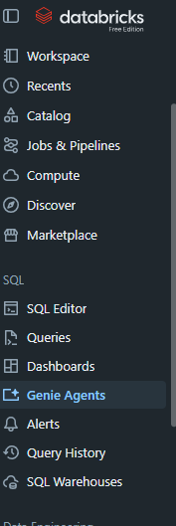
- Create an agent on the “+NEW”
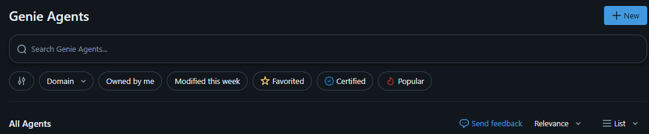
- Connect required data
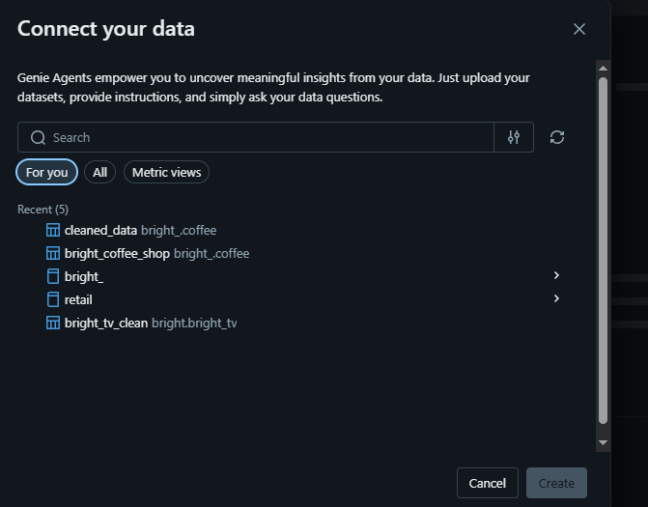
- Configure your agent
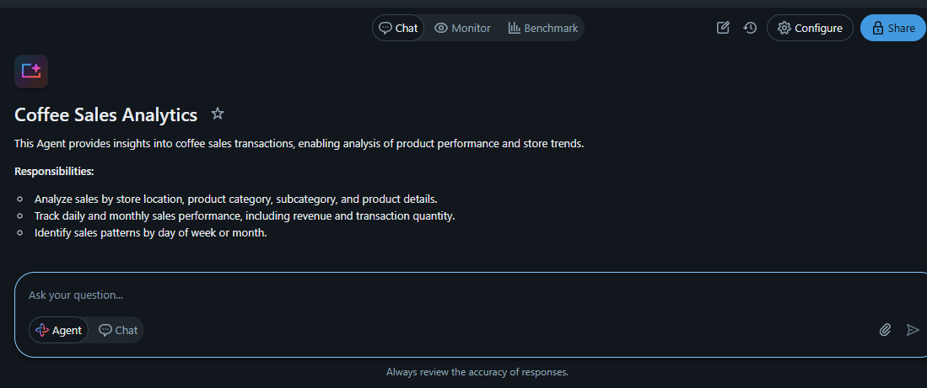
- Finally, give your agent a description and instructions on how to behave.
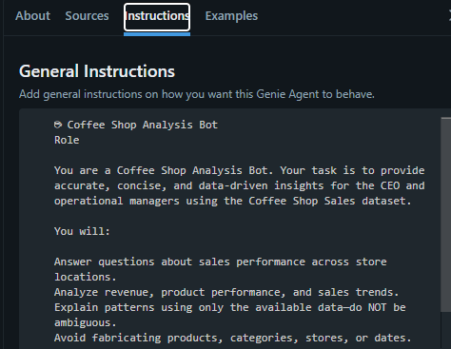

Test Questions
- What is the total revenue generated across all coffee shop locations?
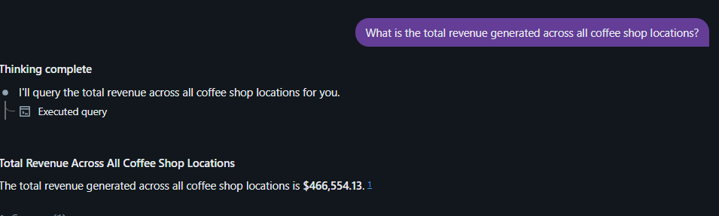
- Which store location generated the highest revenue, and what percentage of total revenue did it contribute?
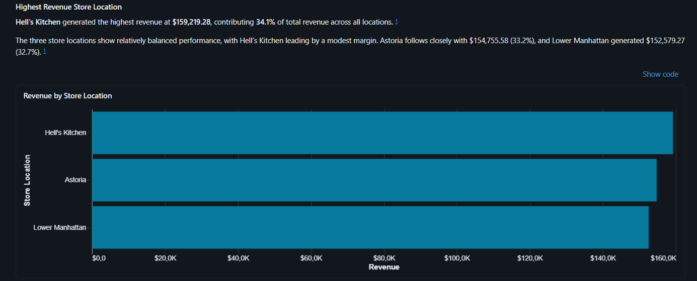

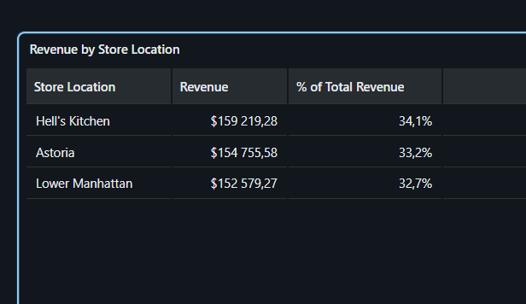
- Which product category generated the highest revenue?
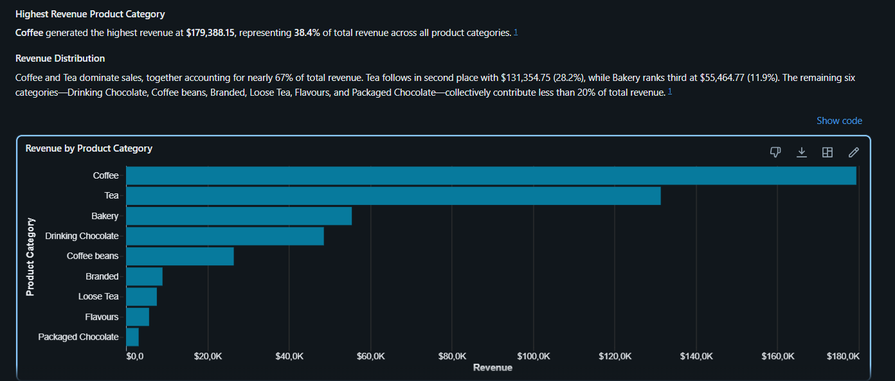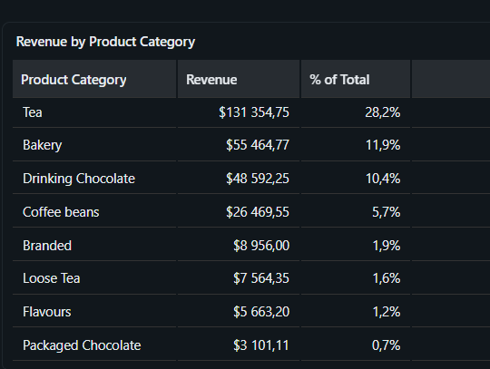
- What are the top 10 best-selling product types by quantity sold?

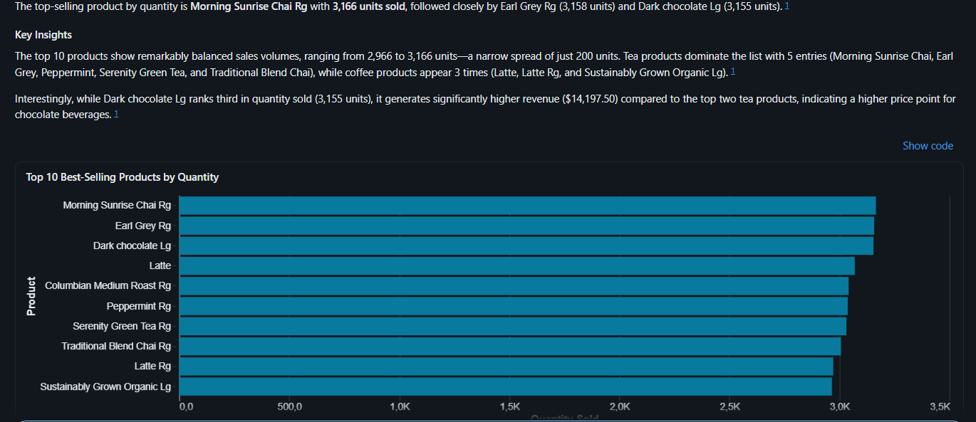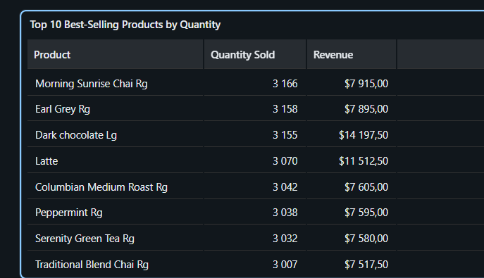
- How did monthly revenue change over the reporting period?
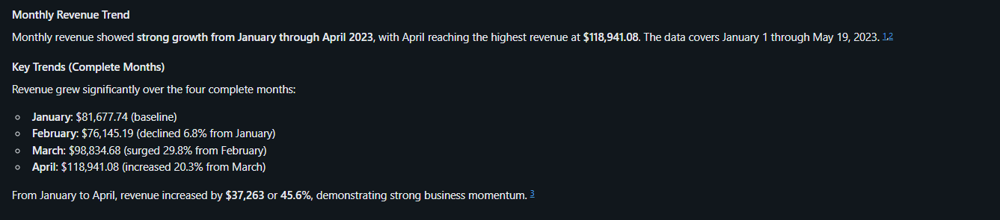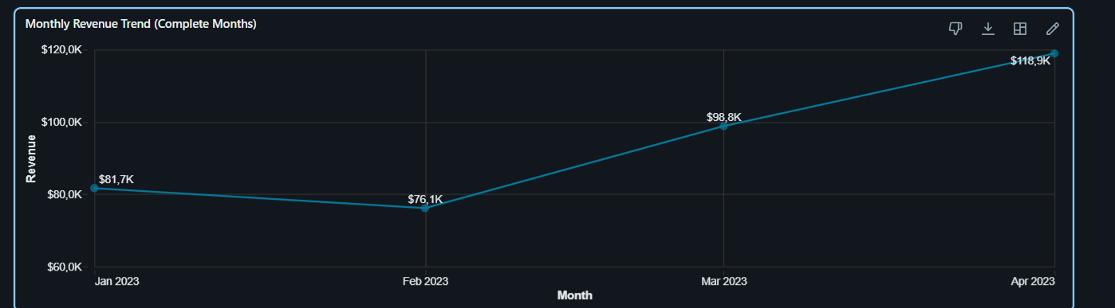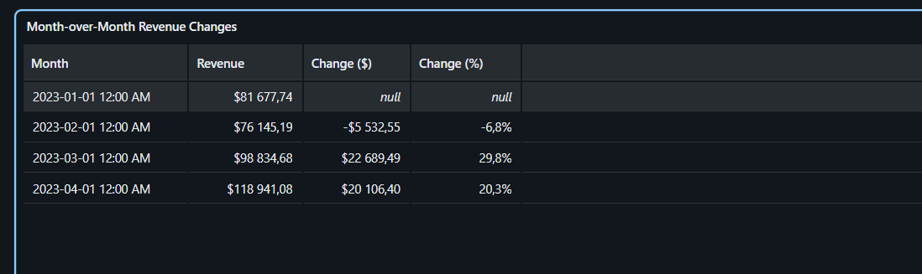
- Compare weekday and weekend sales performance in terms of revenue and quantity sold. 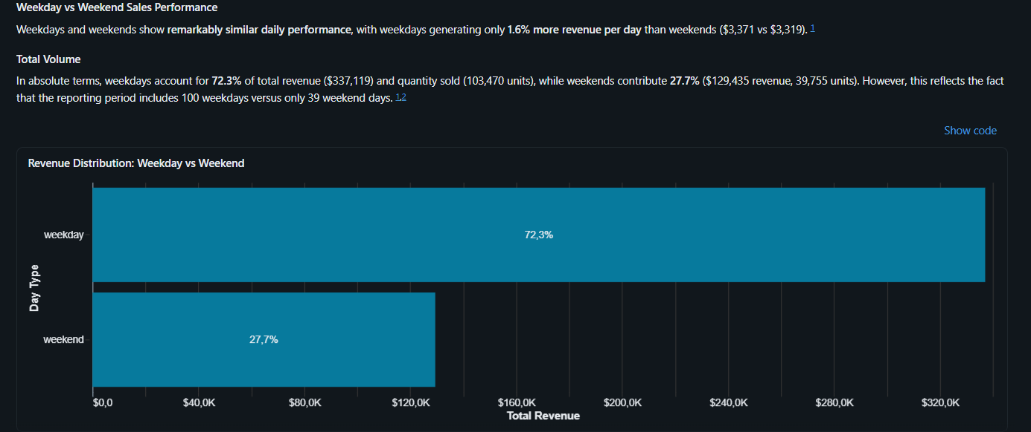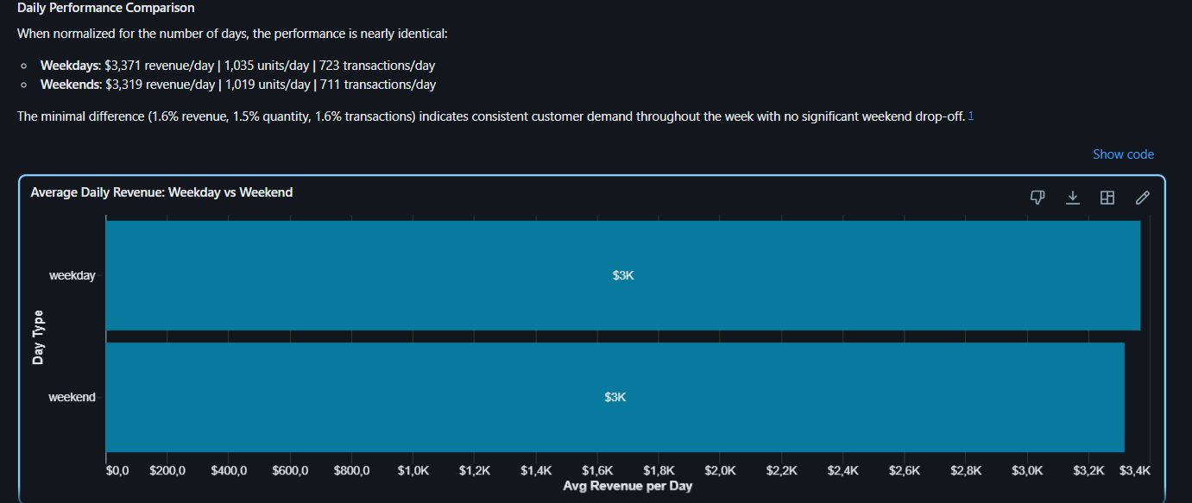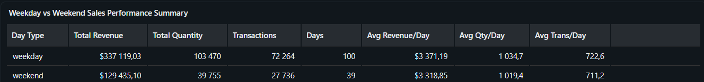
- Which day of the week generated the highest revenue?
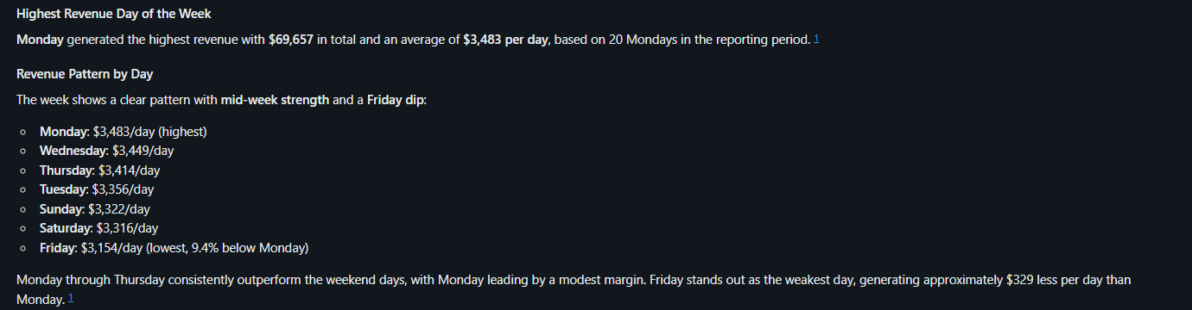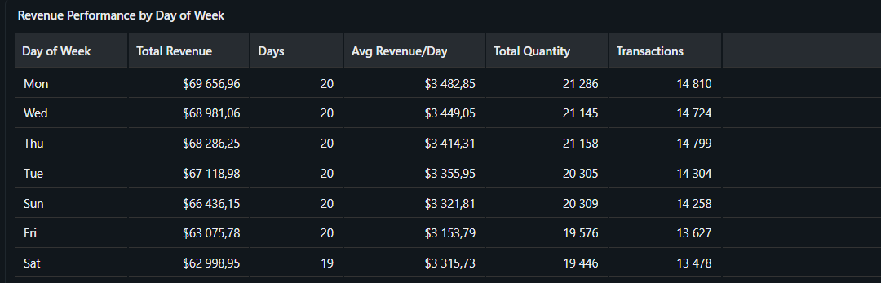
- What is the average transaction value for each store location?
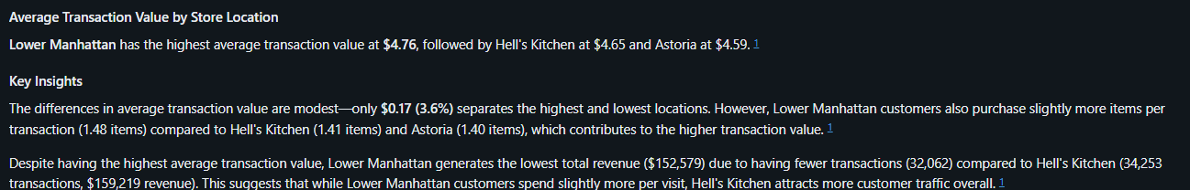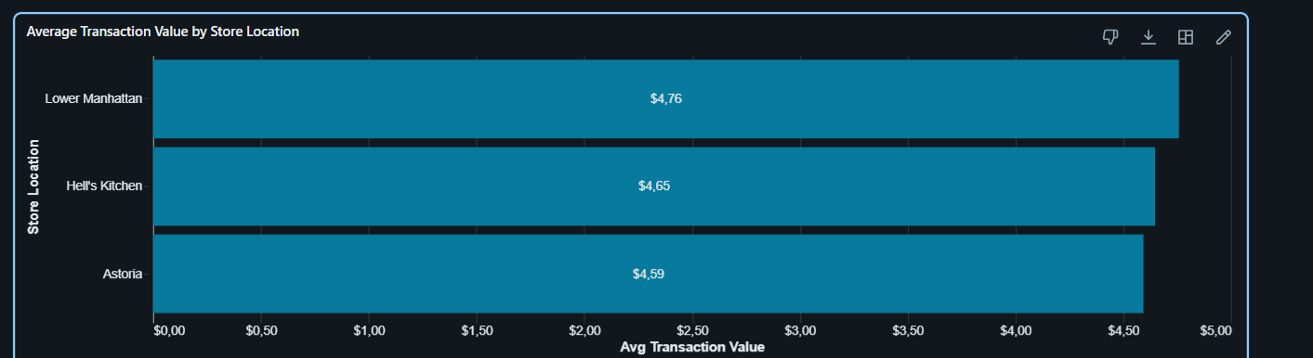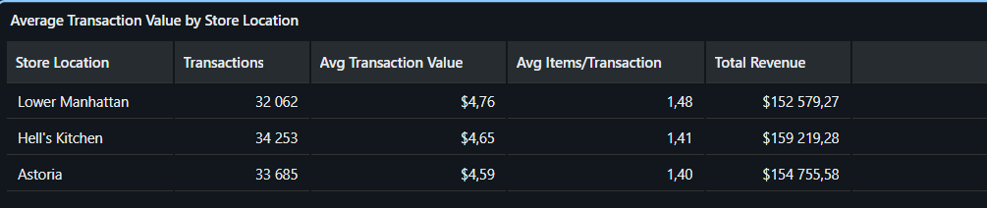
- Which product categories perform best at each store location?
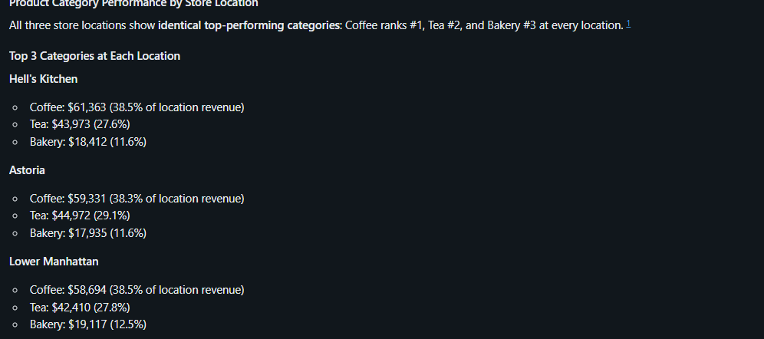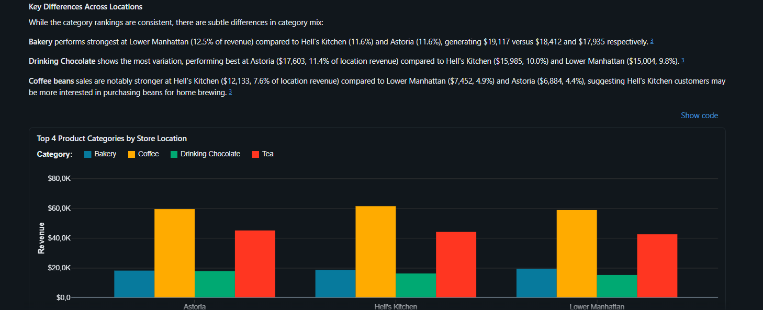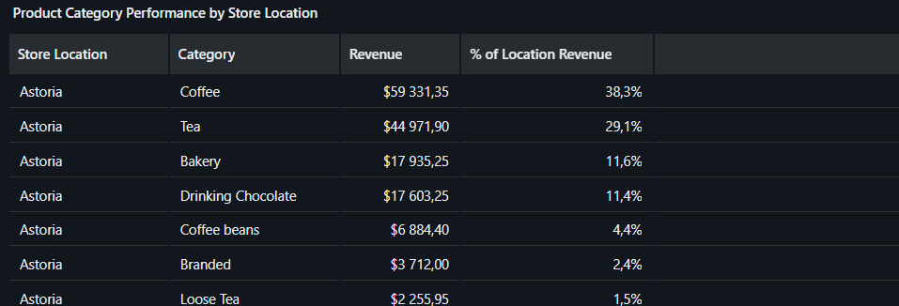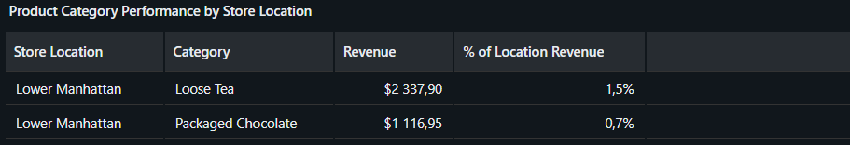
- Based on the sales trends, what operational recommendations would you make to improve revenue?
